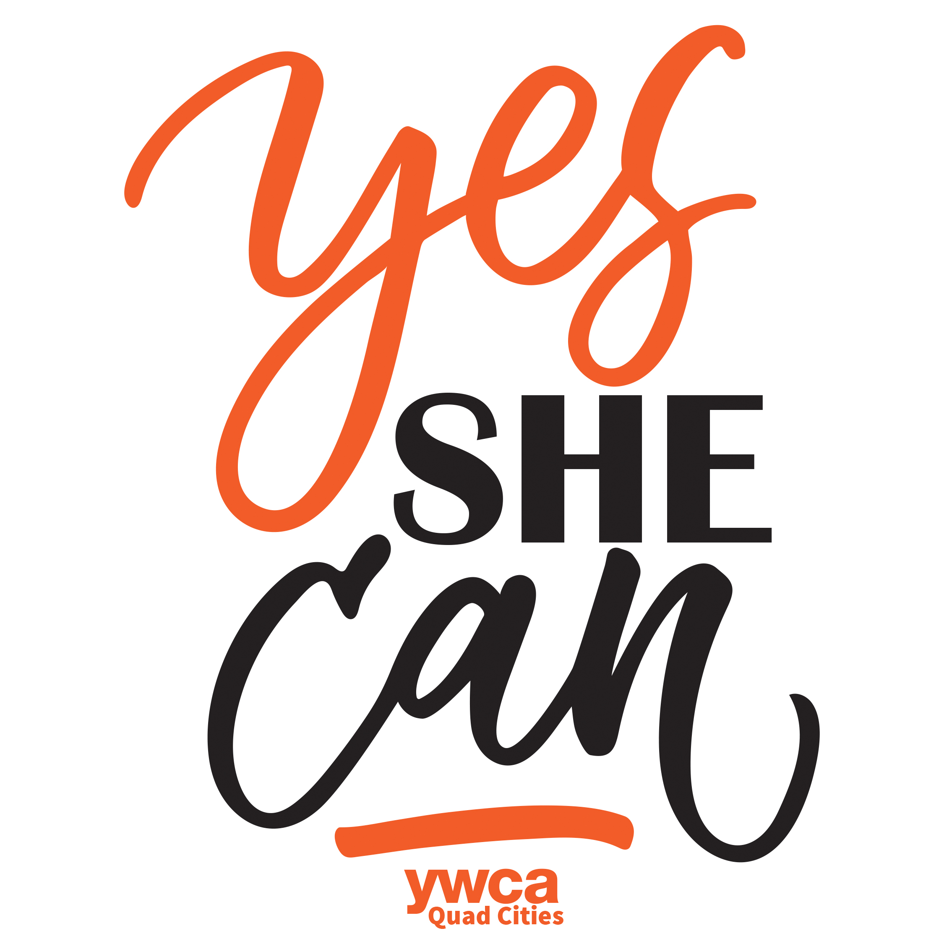
RENEWAL DATE:

(To be filled out by YWCA staff)
Proudly presented by and

INDIVIDUAL MEMBERSHIP REGISTRATION FORM
 | Non-Profit Annual Membership Fee | $200.00

CONTACT INFORMATION:
NAME
COMPANY
MAILING ADDRESS
EMAIL ADDRESS
PHONE NUMBER

Individual registration fee is $100.00/annually and can be paid one of the following ways. Please check which option you prefer:

- $100.00 (check payable to YWCA Quad Cities or cash payment) submitted with this registration form; annual renewals will be sent on October 1 every year thereafter
- $100.00 (credit card payment) submitted with this registration form; annual renewals will be sent on October 1 every year thereafter

Credit Card No: | Exp Date: | Security Code:
Billing Address:
Authorized Signature:

- Please contact me to set up a monthly, quarterly or bi-annual payment plan.

If you have any questions or would like additional information, please contact
Deanna Woodall, Vice President Development & Growth @ dwoodall@qcywca.org or 563.275.8749.

