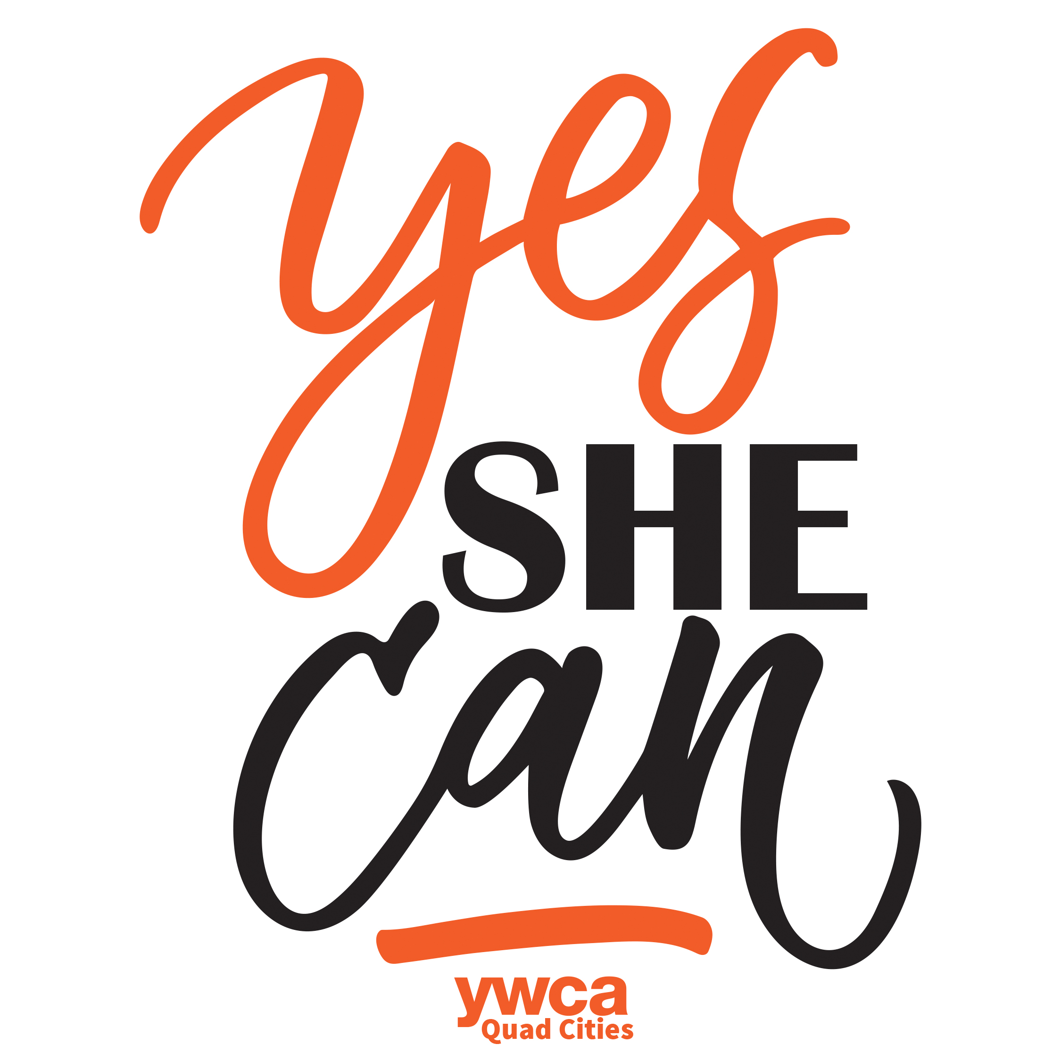

**To uphold the integrity of our legacy, the YWCA Quad Cities has adopted an intentional approach to creating programs and events that align directly with our mission: *eliminating racism, empowering women, and promoting peace, justice, freedom and dignity for all*.**

**The YWCA Quad Cities is launching a new program, which will coordinate a variety of community events, to be presented as The Y(ES) SHE CAN *Series*, with a vision to educate women on various topics and increase awareness on pressing issues facing women and girls. These community events will be open to the public, with a majority having little or no registrations fee. Events will be held throughout the year, with the goal of averaging one event per month. Event topics could include: early childhood education, STEAM education, housing, civil rights, fair wages, sexual assault, health awareness, youth leadership development, self-image, and race relations. The overall goal of this program is to educate, train and empower the community to make a social impact so women and girls can lead a successful career and life.**

**The Y(ES) SHE CAN *Series* is structured similar to a chamber membership model, where individuals pay an annual fee to be a member. All revenue for The Y(ES) SHE CAN *Series* is raised through securing said memberships, which will be used for the sole purpose of providing The Y(ES) SHE CAN *Series* programming. Opportunities for annual sponsor organizations are available, see below.**

|  |  |  |
| --- | --- | --- |
| **DESCRIPTION** | **ANNUAL DUES** | **BENEFITS RECEIVED** |
| **Individual Annual Membership** | **$50** | * **One (1) complimentary registration to any Y(es) SHE CAN SERIES event, if a registration fee applies, with the opportunity to purchase additional registrations at a discounted price** |
|  |  |  |
| **Individual Annual Membership** | **$100** | * **one (1) complimentary registration to any five (5) Y(ES) SHE CAN *Series* events offered throughout the year** * **‘member only’ discounted registration fee to any Y(ES) SHE CAN *Series* events** * **invitation to Y(ES) SHE CAN *Series* ‘member only’ events held throughout the year (at least 2 annually; no registration fee)** * **discount registration fee to any other YWCA event separate and apart from Y(ES) SHE CAN *Series* events** * **name listed on YWCA Quad Cities website as a Y(ES) SHE CAN *Series* member** * **free Y(ES) SHE CAN *Member* t-shirt** |
| **Annual Corporate Sponsorship** | **$500** | * **verbal recognition as an annual corporate sponsor at all Y(ES) SHE CAN *Series* events** * **LOGO recognition as a Y(ES) SHE CAN *Series* annual corporate sponsor on all event materials** * **LOGO recognition on YWCA Quad Cities website as a Y(ES) SHE CAN *Series* annual corporate sponsor** * **speaking opportunity at a Y(ES) SHE CAN *Series* event** * **invitation to Y(ES) SHE CAN *Series* ‘member only’ events held throughout the year (at least 2 annually; no registration fee)** |

We look forward to partnering with you. Together we CAN make a difference as we **educate, train and empower the community to make a social impact so women and girls can lead a successful career and life**. For more information, please contact Deanna Woodall, Vice President Development & Growth @ [dwoodall@qcywca.org](mailto:dwoodall@qcywca.org) or 563.275.8749.

**The Y(ES) SHE CAN *Series***

**Proudly presented by 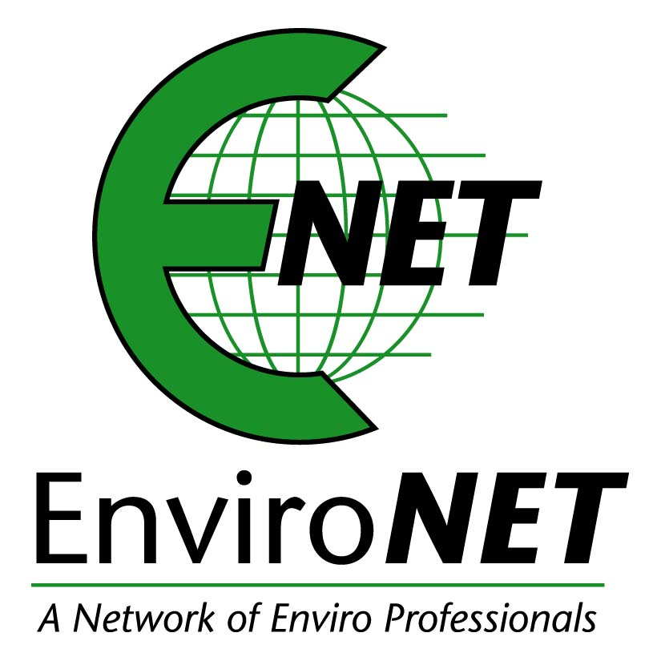 and **

**Information & Overview**